Schiphol (Amsterdam)

Introduction

October the 31st there will be a possible Brexit. So the CEO of a little financial start-up from the U.S. is comparing locations in around Schiphol (Amsterdam) to settle down Europe’s mainland.

Data

I will use data from Foursquare that reveals the financial levels and density of Amsterdam. Using for instance the search_query = 'Financial', ‘banking’, ‘ investment’ and ‘trading’. The radius I used is 25.000 (metres).

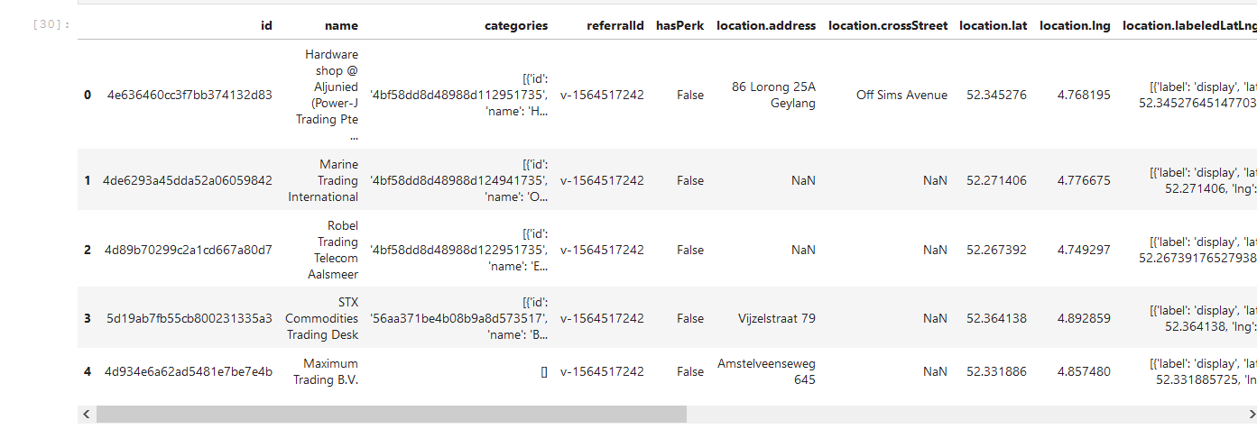

Above: head of the dataframe after transforming it in json_normalize.

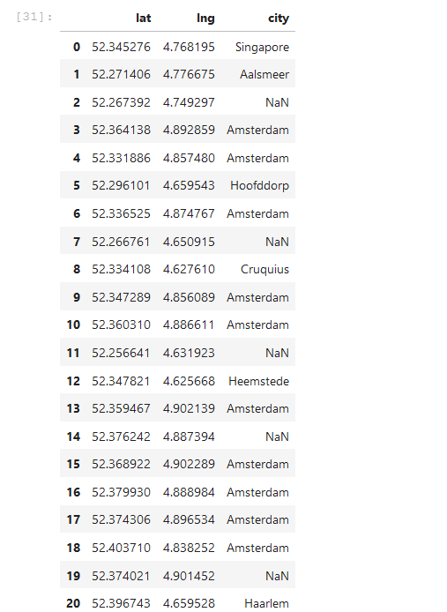

Above: Dataframe after filtering.

Methodology section

Through the Foursquare API in co-operation with the terms for the search_query. With folium I created the following map:

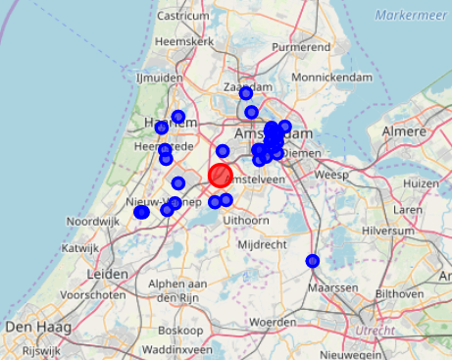

Schiphol in the centre (red circle). Results from the API in the blue.

Results

Most of the financials are in the South West of Amsterdam (between the city centre and Schiphol airport).

The ‘mean’ result of the dataframe:

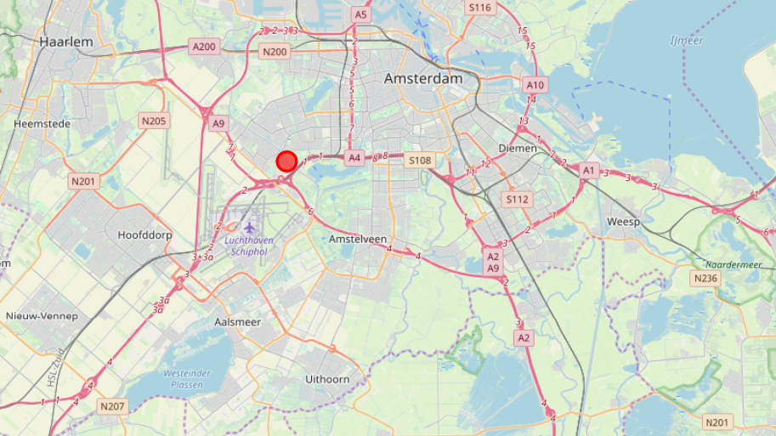

Between Schiphol and Amsterdam city centre.

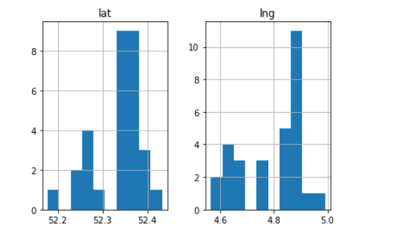

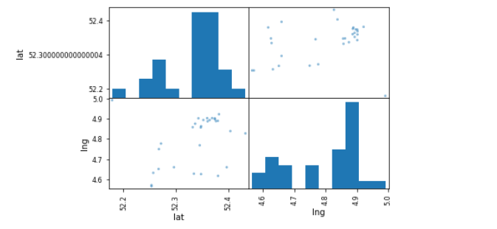

As you can see above, there are a few clusters in and around Schiphol concerning the financials.

Discussion

Take the price of office lease rents. Build a model and use it in the analyse of the perfect location. Maybe it is too high for this start-up. Advice: cost-benefit analysis.

Conclusion

Between Schiphol Airport and the city centre of Amsterdam. See the map beneath.

